Sri Lanka Institute of Information

Technology



Lab Submission

<Lab sheet No 08>

**<IT24103815>**

**<Fernando W.P.S.>**

**IT2120 - Probability and Statistics**

B.Sc. (Hons) in Information Technology

Exercise

1. Calculate the population mean and population standard deviation of the laptop bag weights.

Answer: -

1. Draw 25 random samples of size 6 (with replacement) and calculate the sample mean and sample standard deviation for each sample.

Answer: -

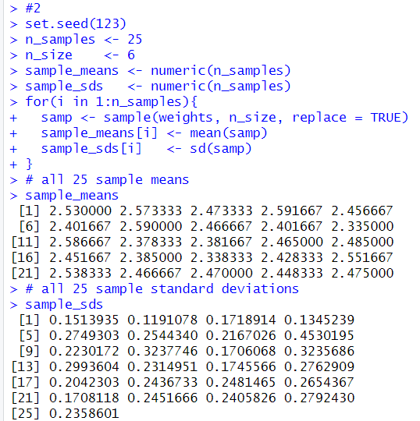

1. Calculate the mean and standard deviation of the 25 sample means and state the relationship of them with true mean and true standard deviation.

Answer: -

